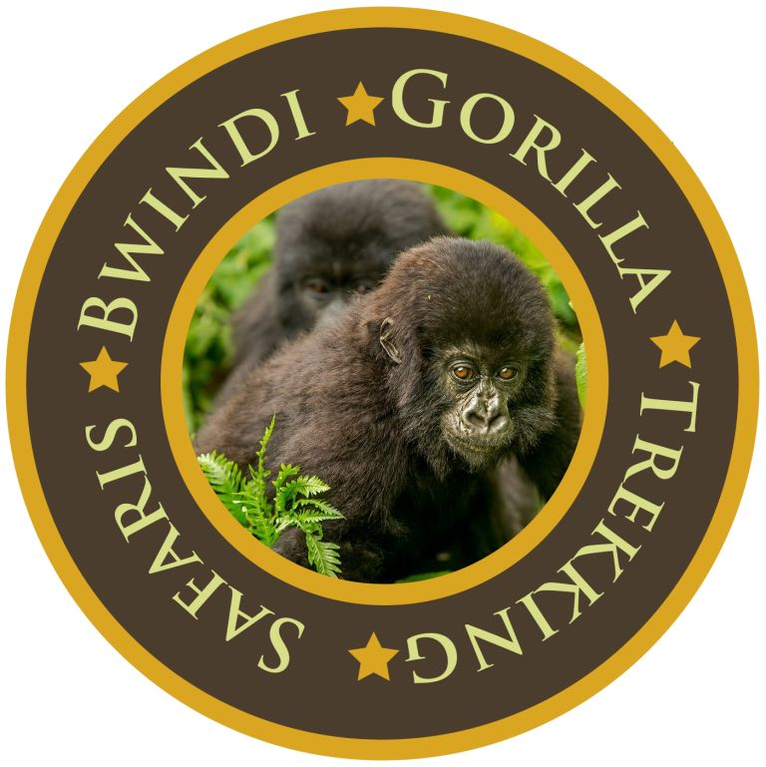

8 DAYS ACROSS RWANDA –AKAGER-VOLCANOES & NYUNGWE EXPERIENCE, 2022

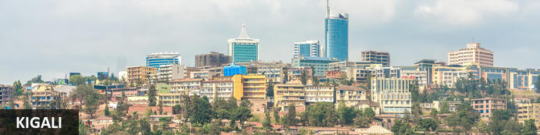
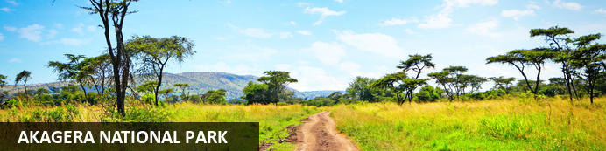
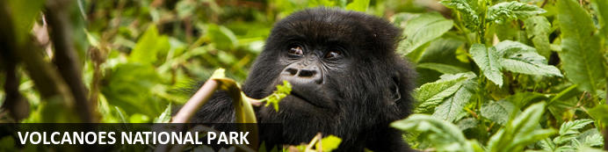
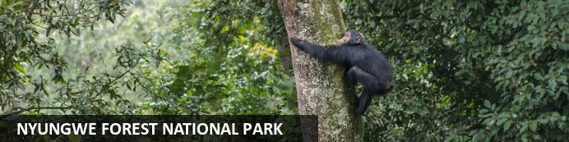

8 DAYS ACROSS RWANDA –AKAGER-VOLCANOES & NYUNGWE EXPERIENCE, 2022
Kigali – Akagera National Park-Volcanoes National Park - Nyungwe Forest National Park
8 Days / 7 Nights
2 Persons
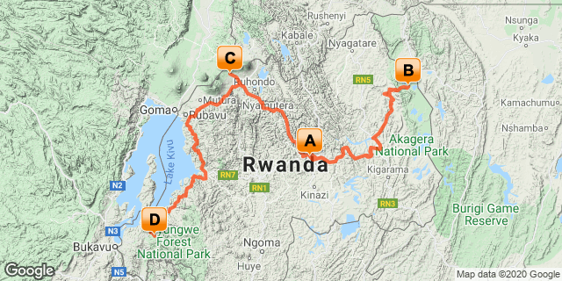

Introduction

Accommodation | Destination | Basis | Room Type | Duration
The Retreat by Heaven | Kigali | HB | 1x Deluxe King Room | 1 Night
Magashi Camp | Akagera National Park | FB+ | 1x Double Tent | 2 Nights
One&Only Gorilla's Nest | Volcanoes National Park | FB+ | 1x Double Room | 2 Nights
One & Only Nyungwe House | Nyungwe Forest National Park | FB+ | 1x Double Room | 2 Nights

Key
HB: Half Board - Dinner, Bed and Breakfast
B&B: Bed and Breakfast
FB: Full Board - Dinner, Bed, Breakfast and Lunch
FB+: Full Board Plus - Dinner, Bed, Breakfast, Lunch and Activities

PRICE
Net cost per person US$ 12,660- Staying at The Retreat, Magashi Camp, Gorillas Nest Lodge (Forest King room), & One & Only Nyungwe House.-(Nyungwe King)

Included
• Meet and greet assistance on arrival
• Airport and inter-hotel transfers from day 1 to the last day
• Accommodation at The Retreat Kigali on Half board basis
• All activities as highlighted in the itinerary
• 2 Nights at Accommodation at Magashi Camp includes: - All meals, All local drinks (excludes premium imported brands and champagne), Laundry, Complimentary in-room welcome massage (**additional massages would be for guest's own account), Wireless internet connection in room only, Local Government taxes. In the event of a change in local taxes
• One & Only Nyungwe House includes breakfast, lunch and dinner daily, minibar, non-alcoholic beverages, alcoholic house beverages with meals and two activities per person per day (as defined by the Resort and subject to change without notice).
• One & only Gorilla's Nest Lodge includes breakfast, lunch and dinner daily, minibar, non-alcoholic beverages, alcoholic house beverages with meals
• Helicopter Flight from Akagera –Volcanoes National Park.
• 1 Gorilla permit per person (this includes briefing at RDB offices, guide, trek – US$ 1500.-)
• 1 Chimp trek permit per person (this includes briefing at RDB offices, guide, trek – US$ 90.-)
• Canopy walk permit per person (this includes briefing at RDB offices, guide, trek – US$ 60.-)
• Exclusive use of a private safari land cruiser 4x4 with WI-FI in receptive areas
•Services of a professional, experienced English speaking driver guide.
•Village/ Cultural Visit in Volcanoes.
•Bottled mineral water in the vehicle during the tour.
•Emergency Medical Evacuation Services.
•Our assistance.

Excluded
- International and domestic airline tickets unless where indicated,
- All extra activities, visits, entrances and extra meals/drinks not mentioned in the itinerary
- Entry visa fees,
- Optional extras whilst in Kigali
- Drinks throughout the trip,
- Tips and gratuities,
- Personal expenses such as telephone calls, mini bar, porter-age, travel insurance, etc.

Day 1: The Retreat by Heaven, Kigali

Kigali
Rwanda’s capital and biggest city stretches across undulating lush hills surrounded by towering mountains, the largest of which is Mount Kigali, rising 1850 metres above sea level. Kigali is the country’s financial, commercial and cultural hub, served by an international airport and featuring a wide range of accommodation options, restaurants and points of interest, including the Kigali Genocide Centre, an atmospheric market and numerous craft shops. With its interesting architecture, busy streets, meandering boulevards, and green hillsides, Kigali is said to be one of the most attractive cities in Africa and is definitely worth a visit.

Day Itinerary
- TBA: Proposed arrival flight time in to Kigali
- TBA: VIP meet & greet through immigration procedures.
- TBA: Pick up from Kigali International Airport for a 25 minutes transfer to Kigali Serena Hotel.
- TBA: Arrival at Serena for Check in.
- TBA: Dinner and overnight stay at the hotel.

Overnight: The Retreat by Heaven
Town & Country and The New York Times call The Retreat in Rwanda one of the top new hotels in the world in 2019. The American owners of Heaven Restaurant created The Retreat, a 12-room luxury boutique hotel located on a tree-lined street steps from Kigali City Center and 20 minutes from the airport. 8 new luxury pool villas are under construction and will be open by December 2020. The Retreat is Kigali’s first eco-friendly resort and features solar electricity, organic toiletries, locally-crafted furniture from a Tanzanian sustainable teak farm, outdoor showers, private terraces, a yoga and meditation room, spa, large heated saltwater swimming pool with jacuzzi and diving rocks, and an open-air fitness center. Fusion Restaurant and its Swahili-inspired bar, located at The Retreat, offer delicious farm-to-table international cuisine, while Heaven Restaurant (reached through the Retreat’s “Stairway to Heaven”) offers an innovative modern African menu. The Retreat is the perfect choice to host guests for 1 night or several days as it offers innovative, curated cultural experiences and exciting activities in and around Kigali. From public health to hospitality, co-owners Alissa & Josh Ruxin created Heaven Restaurant in 2008 to provide jobs and vocational training in hospitality, to date, Heaven and The Retreat have trained over 1000 Rwandans in hospitality skills.
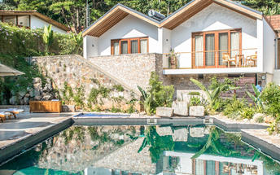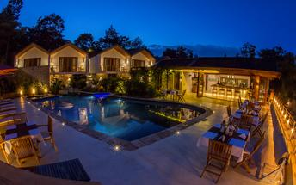

Deluxe King Room
Room size 40 m²
This room features:
1 King bed
Furnished patio
Internet - Free WiFi
Entertainment - Plasma TV with premium channels
Food & Drink - Refrigerator, minibar, coffee/tea maker, complimentary unlimited purified water and 24-hour room service
Sleep - Pillowtop bed, Organic UK Naturalmat mattress, British linens, a duvet, a pillow menu, and turndown service
Bathroom - Private bathroom, rainfall showerhead, organic amenities (shampoo, conditioner, body lotion), single Duravit sink, teak wood vanity
Practical - Safe, desk, and phone, wheelchair accessible
Comfort - Air conditioning and daily housekeeping
Accessibility - Wheelchair accessible
Adjoining - 2 rooms adjoining (beds cannot be setup as Twin)
Non-Smoking
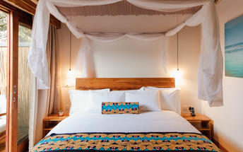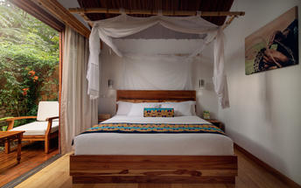

Basis
Half Board - Dinner, Bed and Breakfast

Day 2: Magashi, Akagera National Park

Akagera National Park
Bordering Tanzania in eastern Rwanda, Akagera National Park is central Africa's largest protected wetland and the last refuge for savannah-adapted species in the country. Stretching across a vast expanse of low-lying mountains and savannah plains, the park takes in the rolling highlands woodlands, swamp-fringed lakes, and wetlands of the Kagera River along the way. Crocodiles and hippos wallow in the park's watery basins, predators prowl through its acacia groves, and elephant, zebra, giraffe, buffalo and other animals roam across its grassy plains. Bursting with a rich biodiversity, the park features a variety of rare species, as well as a plentitude of mammals and hundreds of bird species.

Day Itinerary
- 0700: Begin the day with a morning breakfast.
- 0800: Transfer to Akagera National Park to the Northern gate.
- 1030: Arrival at the Akagera National Park. North gate.
- 1100: Get into Magashi Camp Game drive safari vehicles and be transferred to Magashi.
- 1200: Arrival at Magashi Camp and check-in.
- 1300: Lunch and afternoon activities by the lodge.
- 1800: Dinner and overnight stay at Magashi Camp.

Overnight: Magashi
Magashi Camp is situated in the productive and phenomenally diverse north-eastern corner of Akagera National Park, overlooking scenic Lake Rwanyakazinga. Akagera comprises some of the most scenic savannah in East Africa – open plains, woodlands, lakes, swamp and grassy low mountains – and is home to one of Africa’s highest hippo densities, large crocodiles, as well as the rare sitatunga and almost 500 species of birds. Teeming with plains game, Akagera also boasts a healthy population of lion which were introduced by African Parks in 2015 after a 20-year absence; black rhino were reintroduced in 2017. Magashi – the only exclusive-use area in Akagera – also harbours a good density of leopard.
INSIDER'S TIP: Our core Purpose in Akagera is to help conserve Rwanda’s last protected savannah ecosystem, and species like black rhino and the rare and elusive shoebill; furthermore, our presence here will contribute towards enabling it to become economically self-sufficient for the first time.
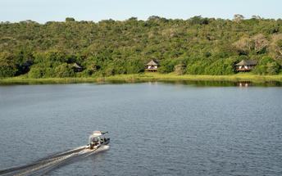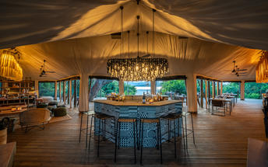

Basis
Full Board Plus - Dinner, Bed, Breakfast, Lunch and Activities

Day 3: Magashi, Akagera National Park

Day Itinerary
- 0630: Begin the day with a morning breakfast.
- 0700: Morning game drive in Akagera National Park and other days activities by the lodge.
- 1400: Boat safari in Akagera on Lake Rwanyakizinga.
- 1800: Dinner and overnight stay at Magashi Camp.

Activities
Magashi Game Drives
Magashi Boating

Magashi Game Drives
Explore the area in an open 4x4 vehicle with each vehicle able to accommodate a maximum of seven guests, allowing each individual an outside seat.

Magashi Boating
Magashi offers boating in eight-seater swamp cruisers. This is an excellent way to view the water birds and many other aquatic animals seen around Lake Rwanyakazinga.

Basis
Full Board Plus - Dinner, Bed, Breakfast, Lunch and Activities

Day 4: One & Only Gorilla's Nest, Volcanoes National Park

Volcanoes National Park
Bordering the Democratic Republic of Congo in Rwanda, and set high on the jungle-covered slopes of the volcanic Virunga Mountains, the Volcanoes National Park is best known as a sanctuary for the region’s rare mountain gorillas. Visitors flock here to experience face to face encounters with these intriguing creatures. Regulated treks through the reserve allow visitors to spend an hour at a time with these incredible primates in their natural habitat. While the gorillas are without a doubt the main draw card, visitors can also look forward to exploring a network of scenic hiking trails, with the beautiful day hike to the Crater Lake on Mount Bisoke being a particular highlight. Make sure to visit the fascinating Karisoke Research Centre and the tomb of the world-famous Dian Fossey.

Day Itinerary
- 0800: Begin the day with a morning breakfast.
- 0900: Ready for your helicopter flight to Volcanoes-(One & Only Gorillas Nest) R44 Helicopter
- 1000: Fly to Volcanoes National Park.
- 1100: Arrival at the Musanze Airstrip.
- 1130: A short transfer to Gorillas Nest Lodge and check-in.
- 1300: Lunch at the Resort.
- 1500: Take part in complementary activities at the Lodge.
- 1800: Dinner and Overnight stay at One & Only Gorillas Nest Lodge.

Overnight: One&Only Gorilla's Nest
One & Only Gorilla's Nest is situated right in the foothills of the Volcanoes National Park, creating the opportunity for a once in a lifetime rare personal encounter with a majestic mountain gorilla. Hidden amongst the trees this hotel is unique, surrounded by flourishing wildlife. The cabins and suites are more than cosy, each with an elegant and luxurious interior is fitted with a minibar, a flat-screen TV and complimentary Wi-Fi. Guests may enjoy a complimentary breakfast each morning, there is also an on-site restaurant serving only the best cuisine. There are activities available at the establishment such as guided gorilla treks and wellness workshops.

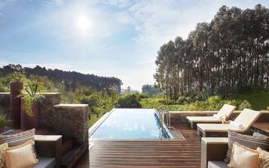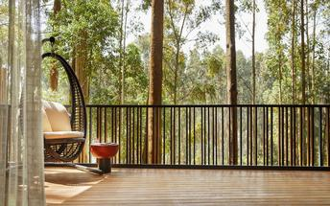

Basis
Full Board - Dinner, Bed, Breakfast and Lunch

Day 5: One&Only Gorilla's Nest, Volcanoes National Park

Day Itinerary
- 0600: Begin the day with a morning breakfast.
- 0630: Transfer to the park headquarters for gorilla trekking briefing.
- 0800: Start the gorilla trekking in Volcanoes National Park.
- 1200: Estimated time of returning from the jungle.
- 1230: Transfer back to the Lodge.
- 1300: Lunch at the Lodge.
- 1500: Visit to Iby ‘Iwacu cultural village.
- 1800: Dinner and overnight stay at One & Only Gorillas Nest Lodge.

Activities
Gorilla Trekking Volcanoes National Park
Iby ‘Iwacu Cultural Village

Gorilla Trekking Volcanoes National Park
Gorilla Trekking in the Volcanoes National Park offers visitors the unique opportunity of discovering the 10 families of gorillas that live within the national park. Visitors can enjoy a cup of coffee before the trek starts and will be separated into groups of 8 depending on their physical abilities. Each group is guided by a guide and two scouts who are well trained in emergency situations. The amount of time set aside per trek is different depending on where the gorilla family is situated. Some trips may take as little as half an hour and some taking the better part of the day.

Iby'Iwacu Cultural Village
Offering an adventurous stay in a traditional rural, Rwandan village that has existed for centuries living with and next to mountain gorillas in Parc National des Volcanos. Iby ‘Iwacu Cultural Village gives you a rare chance to meet local people, in their environment, with a taste of our culture and traditions. The community you visit will genuinely welcome you as a special guest while they proudly present to you aspects of their traditions and beliefs. This will truly be an experience of a lifetime as you home stay with the community and become part of their family

Basis
Full Board - Dinner, Bed, Breakfast and Lunch

Day 6: One & Only Nyungwe House, Nyungwe Forest National Park

Nyungwe Forest National Park
Situated in south-western Rwanda, the Nyungwe Forest National Park is known for its exceptional biodiversity and its wide range of endemic species. The park is composed of lush tracts of rainforest set high up on fertile mountain slopes. It is one of Africa’s most ancient forests and the home of Rwanda’s sole remaining chimpanzee population, as well as 85 additional mammal species, 43 reptile species, nearly 300 bird species and over 1000 plant species. Visitors can enjoy spotting Colobus monkeys and chimpanzees hiding in the trees, hiking on a well-maintained network of trails passing through lush equatorial rainforest and catching a glimpse of a beautiful array of colourful birdlife. Don’t miss the thrilling Canopy Walk, it is one of its kind in Africa and offers impressive views of the forest.

Day Itinerary
- 0800: Begin the day with a morning breakfast.
- 0830: Prepare for a transfers to Nyungwe Forests.
- 1300: Estimated time to arrive at Nyungwe forests.
- 1330: Take on an early lunch at the Lodge.
- 1600: Take part in the Complimentary Lodge activities.
- 1800: Overnight and dinner at One &Only Nyungwe Lodge.

Overnight: One & Only Nyungwe House
One&Only Nyungwe House is set amongst the rich tea-plantations of Gisakura, In Southwest Rwanda, just south of Lake Kivu on the Burundi border. The property is set on the edge of the iconic Nyungwe National Park, which covers approximately 1020 square kilometers of rainforest, bamboo, and swamps. The accommodations at this lodge provide a sense of tranquility with a fireplace and picturesque private deck. All rooms include breakfast, lunch, and dinner while featuring tea and coffee facilities and an en-suite bathroom with an indoor shower, wilderness-view shower and stand-alone bath.
The One&Only Spa provides relaxing treatments, while the One&Only Gym allows guests space and equipment for a refreshing workout. Additionally, guests can relax in the infinity pool while having a snack and drink and enjoy a meal by the trees with a picnic or at the elegant restaurant.
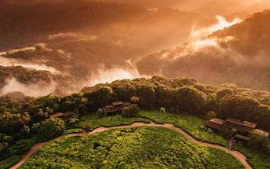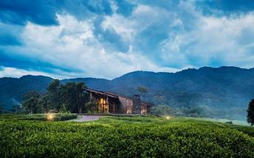

Basis
Full Board Plus - Dinner, Bed, Breakfast, Lunch and Activities

Day 7: One & Only Nyungwe House, Nyungwe Forest National Park

Day Itinerary
- 0500: Begin the day with a morning breakfast.
- 0530: Prepare for transfers to Park headquarters for Chimpanzee trek briefing.
- 0530: Start the Chimpanzee trekking in Nyungwe forests.
- 1230: Estimated time to return from the jungle.
- 1330: Lunch at the Lodge and entire day relaxing and winding at the Lodge.
- 1500: Take on a Canopy Walk experience
- 1800: Special Dinner arrangement in the Tea Plantation.

Activities
Nyungwe Forest National Park Cyamudongo Forest Chimpanzee Trekking
Canopy Walk

Nyungwe Forest National Park Cyamudongo Forest Chimpanzee Trekking
Located within the Nyungwe National Park, the Nyungwe Forest National Park Cyamudongo Forest Chimpanzee Trekking provides visitors with a unique chimpanzee experience. Visitors will follow a path through the lush vegetation to a point where they will be able to witness the chimpanzees acting out their daily activities, such as waking up, eating and socialising within their natural environment.

Canopy Walk
Suspended above ravine amidst the lush vegetation and montane forest of the Nyungwe National Park, Canopy Walk offers participants an exhilarating perspective atop the ancient treetops and wildlife. The 160 meters long suspended bridge is accessible as a part of a guided hike along the Igishigishigi trail or those hiking the Imbaraga and Umuyove trails.

Basis
Full Board Plus - Dinner, Bed, Breakfast, Lunch and Activities

Day 8: End of Itinerary

Day Itinerary
- 0800: Begin the day with a morning breakfast.
- 0830: Relaxing and chilling at the hotel.
- 1200: An early lunch at the Lodge.
- 1300: Prepare for a return transfer back to Kigali.
- 1400: Visit the Ethnographic Museum.
- 1420: Return to Kigali at your convenience
- 1700: Proposed time of arrival in Kigali and transfer to Kigali International Airport.
- 1730: Check in for your outbound flight to your next destination departing at 2125.

Activities
Ethnographic Museum Rwanda

Ethnographic Museum Rwanda
Located in Huye, south of Kigali, Ethnographic Museum is one of the six museums that make up the Institute of National Museums of Rwanda. This Museum was built in 1987, and now houses one of Africa's finest ethnographic collections. Its seven galleries display historical, ethnographic, artistic and archaeological artefacts accompanied by visual aids, giving visitors a rich insight into the culture of Rwandans.

Basis
Breakfast and Lunch

