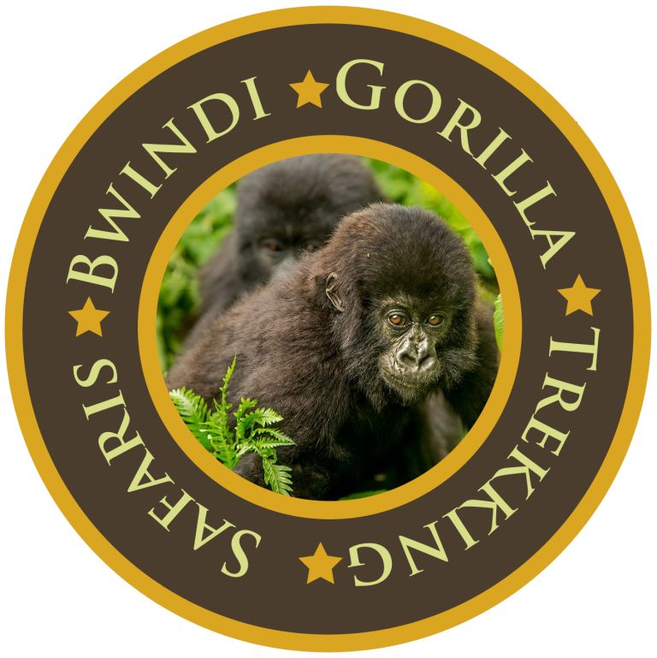
BGTS 7 days MOUNTAIN gorilla TREKKING SAFARI & Masaai mara EXPERIENCE - FLYING safari
Entebbe- Bwindi Forests National Park-Entebbe –Masaai Mara.
Safari Overview: Tailored for travel between July and September, this new safari offers you a nice opportunity to encounter Gorillas; the shy yet gentle giants of Bwindi National Park as well as get up close with Masai Mara’s BIG 5, and yes…. The annual wildebeest migration between Serengeti and Masai Mara, a wildlife spectacle that many discerning travelers are seeking to tick off their bucket list. You travel between Bwindi and Masai Mara by flight, with breakfast in Bwindi, and lunch in Masai Mara, saving you several hours in driving time.

Day 1: Arrival Entebbe Airport.

Upon arrival at the airport, you will be warmly welcomed by our guide who will then take you to Hotel No.5 (Luxury facility) for an overnight and dinner. Meal plan Dinner.

Day 2: Entebbe-Bwindi Forest national Park.
Our guide/driver picks you at from your hotel in Entebbe for your transfer to Entebbe International Airports to catch up with a morning scheduled flight to Bwindi. Flight departs Entebbe at 0700- Arriving Kihihi at 0835. You will enjoy the Ariel view of the beautiful changing Landscape. The flight is only for 2 hours o the lushest highland rain forest on earth, filled with primates and exotic birds, valleys, hilltops and papyrus swamps.
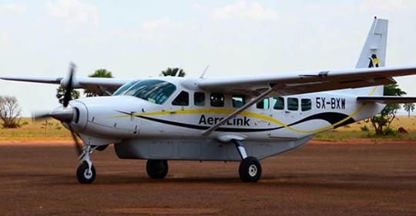
On your arrival to Kihihi airstrip, you will be transferred with our vehicle to you Lodge. Upon arrival, you will have a Batwa experience. Dinner and overnight stay at Sanctuary Gorilla Forest Camp/Bwindi Lodge (Luxury facility) Meal plan: Breakfast, Lunch and Dinner.

Day 3: Bwindi Gorilla Trekking & Community/Village Visit.
Begin the day with breakfast ready for trekking, which begins at 8:00 am with a briefing from the UWA staff. Ensure to carry along with you rain jacket, drinking water, snacks, jungle boots etc The guides will lead you inside the jungle to see the shy Primates for a group you have been booked for. Do not forget to take your lunch boxes and all the necessary gear to track the rare Mountain Gorilla, perhaps one of the most exciting wildlife experiences on earth. The tracking may take between 2 and 6 hours but it’s well worth the effort.
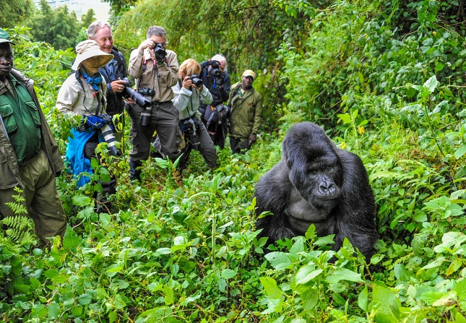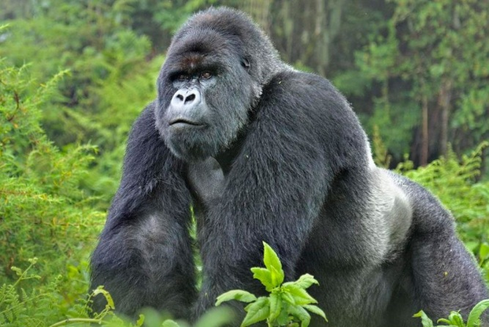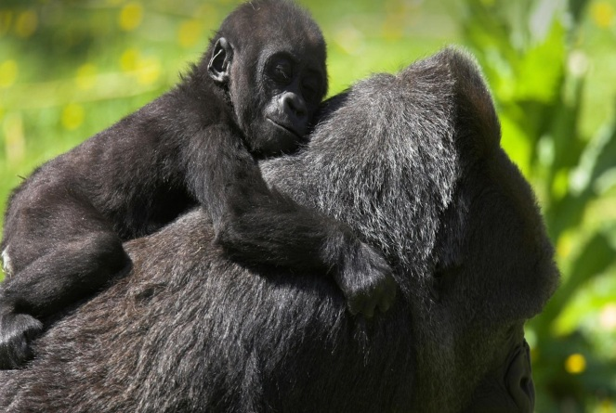
The afternoon is spent on a village walk. The Buhoma village walk gives you a great opportunity to see how the people surrounding Bwindi Impenetrable Forest. It also is a great way to support the local community in a direct way. The walk begins with your guide from your camp and is most informative, rewarding to the average visitor. It will amaze you how resourceful the local people are as you see and learn their ways. Dinner and overnight stay at Sanctuary Gorilla Forest Camp/Bwindi Lodge (Luxury facility) Meal plan: Breakfast, Lunch and Dinner.
Day 4: Bwindi to the Airstrip fly back to Entebbe. Flight time to Mara at 12:10

Morning transfer at the airstrip for your flight at 0925 arriving Entebbe at 1125. Upon arrival ready for your connecting flight operated by Air Kenya to Masaai Mara. Arriving at the local airstrip at around 1345 hrs. Met and proceed to your tented camp for lunch. You then enjoy your first game drive in the world famous Masai Mara, the beginning of your up-close encounter with the Big Cats and many other mammal and bird species. Overnight stay at And Beyond Kichwa Tembo Camp/ similar. Meals: Breakfast, Lunch, Dinner.

Day 5: & Day 6: Masai Mara Discovery

Depending on the Wildlife migration patterns and the weather, early morning breakfast followed by two full days of unlimited game drives within the reserve. The Masai Mara is famous for its black manned lions and the annual wildebeest migration. This is probably one of Kenya’s most visited reserve with an extraordinary density of animals including the Big five and many other varieties of plains game. The Mara River cuts through the Mara and Serengeti eco systems giving life to the both reserves before finally pouring out into the Lake Victoria. Impressive and most notable is the wildebeest, zebra and gazelle instinct led migration from the Serengeti in Tanzania to the Mara in Kenya. This journey is coupled by numerous obstacles which makes it even more magnificent. You will have a picnic lunch and continue with the game drives arriving at the lodge in the evening for a well-deserved rest and hot relaxing shower. Accommodation at And Beyond Kichwa Tembo Camp/similar Meal plan: Breakfast, Lunch and Dinner.

Day 7: Departure:

Breakfast. Check out and board your safari converted land cruiser. (Optional flight back to Nairobi available). Drive back to Nairobi with a stopover as you drive up the floor of the Great Rift Valley. Lunch will be on own account. Transfer to the Jomo Kenyatta International Airport on time for your evening / night departure flight, marking the end of a signature safari covering two of East Africa’s leading safari attractions. Meals: Breakfast. End of services.

